

Using Our Inventor Add-In Software

Installation and Use Guide

2017

Table of Contents

Installation 2

Running The Installer 2

New Ribbons 2

Part Ribbon 2

Assembly Ribbon 2

Usage 3

Part Information Form 3

Bill of Materials Form (Part) 4

Bill of Materials Form (Assembly) 5

Routing Form 6

Hardware Insert Form 7

Check Imports Form 7

Save Formats Form 8

Quick .DXF Button 8

All Information Form 9

License 10

# Installation

## Running The Installer

1. To install the Add-In Software navigate to *H:\Interface* Test Docs one the server.
2. Run the Installer called “AddInInstaller”.
3. 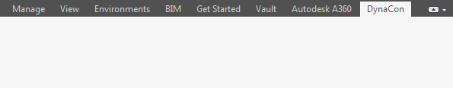Now open Inventor and check to see if the new DynaCon Ribbon tab has been created to ensure proper installation.

# New Ribbons

## Part Ribbon

When an Inventor part file (.IPT) is open, you will have access to these commands:

* Import part master information to Manage 2000.
* Import bill of materials to Manage 2000.
* Import routing information to Manage 2000.
* Access all information in Manage 2000 associated with current part.
* Save the part in different formats.
* Quickly make a .DXF file to send to the CNC router.

## Assembly Ribbon

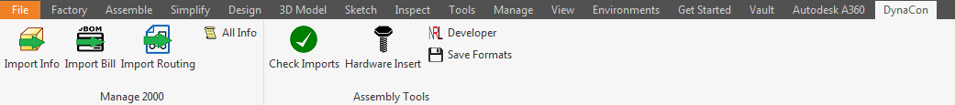When an Inventor assembly file (.IAM) is open, you will have access to the same commands as the part ribbon in addition to these:

* Checking to make sure the files in your assembly have had all their information pushed to Manage 2000
* Use the multiple insert tool to quickly add hardware to an assembly.

# Usage

### Part Information Form

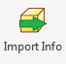Accessible: Assembly and Part Ribbons.

Button:

**Fields**

1. Indicates Part Number.
2. Short description of part.
3. How the part will be measured.
4. Complete detail description of part.
5. Indicates finished product or raw material
6. Where it is available, not for sale etc.
7. Category of the part
8. Is it made in shop or purchased.
9. Customer the part is being made for.
10. Sales order number of part
11. Designer of part.
12. Manufacturer name (Purchased)
13. Manufacturer number (Purchased)

**Buttons**

1. Help button that displays the meanings of all the options in drop down menus.
2. Button that auto-selects some options to make it a purchased part.
3. Button that auto-selects some options to make it a manufactured part.
4. Saves information and uploads it to Manage 2000.
5. Saves information locally
6. Cancels current updates.

**What It Does**

This form will allot the user to create or update part information in Manage 2000. It will take some information already created in Inventor and automatically fill out this portion.

### Bill of Materials Form (Part)

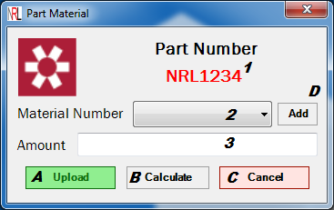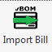Accessible: Part Ribbon.

Button:

**Fields**

1. Indicates Part Number.
2. Material to be used by part.
3. Amount of material used in square inches.

**Buttons**

1. Uploads material information to Manage 2000.
2. Prompts the user to select the cut  
   of the part and calculates the   
   square inches.
3. Cancels the transaction.
4. Allows the user to add a custom material to the drop down list.

**What It Does**

This form will allow the user to add or update the bill of materials for a part in Manage 2000. This form will only open when the user is in a part document. Otherwise the Assembly Bill of Materials form will open.

### Bill of Materials Form (Assembly)

Accessible: Assembly Ribbon.

Button:

**Fields**

1. Here you will be able to add a custom part into the bill of materials. *Note: It is highly suggested not to do this through inventor, but the option is available.*

**Buttons**

1. Uploads material information to Manage 2000.
2. Cancels the transaction

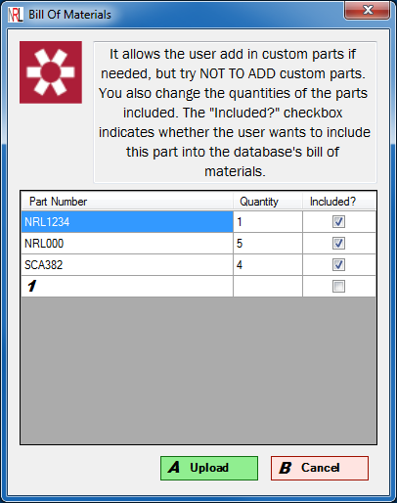**What It Does**

This form will allow the user to add or update the bill of materials for an assembly created in Inventor. It will automatically gather all the parts used in the assembly and their quantities. The user can create new parts within this form to add them to the bill of materials. But it is recommended not to do this. The check box on the right side of the table indicates whether or not to include this part in the bill. Only parts that have this selected will be included in the bill of materials.

### Routing Form

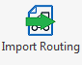Accessible: Assembly and Part Ribbons.

Button:

**Fields**

1. Indicates Part Number.
2. New routing sequence number.
3. Where the sequence will happen.
4. Amount of people required for assembly.
5. Amount of time needed for this part.
6. Explaining what this task is for.
7. Area where all current sequences are stored.

**Buttons**

1. Quick access button that adds sequence 10, 20, and 30 for cutting, rounding and tapping.
2. Quick access button for sequences 10 and 20.
3. Quick access button for sequences 10, 20 and 30 for cutting, rounding and bending.
4. Quick access button for sequence 10 for assembling.
5. Uploads all information in table 7 to Manage 2000.
6. Adds sequence defined in fields 1-6 to table 7.
7. Cancels the current transaction.
8. Retrieves the current routing information associated with the part.

**What It Does**

This form will allow the user to add or update the routing information to Manage 2000.

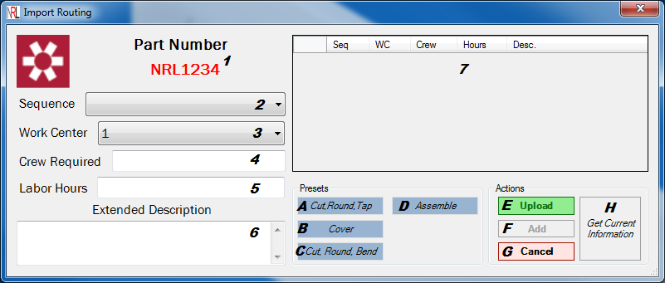

### Hardware Insert Form

Accessible: Assembly Ribbon.

Button:

**Buttons**

1. Prompts user to select one circular edge of hardware.
2. Prompts user to select 1 or more circular edges where the user wants this hardware inserted.
3. Finalizes the transaction and inserts hardware.
4. Cancels the transaction.

**What It Does**

This form will allow the user to select the edge of piece of hardware in the assembly. Then select each individual hole where they want this piece of hardware inserted. Once the user has selected each hole, a new instance of hardware will be created and an insert constraint will be added to it to put it in the hole.

### Check Imports Form

Accessible: Assembly Ribbon.

Button:

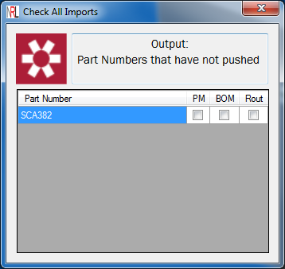

**What It Does**

This form will shows the user what information has been pushed for each individual part in the assembly. If the information has been added to Manage 2000, it will show a check mark in the box. Only the parts that do not have all the information added will be shown.

### Save Formats Form

Accessible: Assembly, Drawing, and Part Ribbons.

Button:

**What It Does**

This form allows the user to select the file types to save a drawing as. Then it will ask the user where they want to save the documents and it will save this drawing as these formats in the desired folder.

### Quick .DXF Button

Accessible: Part Ribbon

Button:

**What It Does**

This button will not open a form, but it will open a new .DXF drawing file. This will take the current front view of the part and create a file to use for a CNC router. If you are creating a flat pattern of a bent part, answer yes in the sheet metal dialog. This will create a flat pattern view of your part. If you are creating a .DXF file for a non-bent part, then answer no.

### All Information Form

Accessible: Assembly and Part Ribbons

Button:

**What It Does**

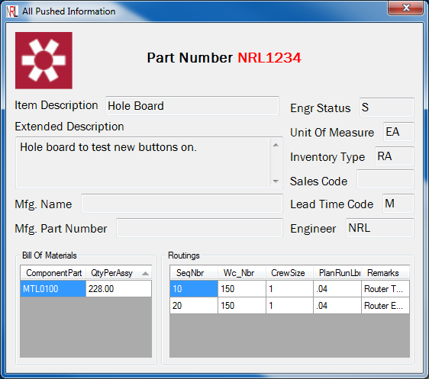This form will show all information associated with a part or an assembly that has been pushed into Manage 2000. Nothing can be edited from here, it used just as a check or reference.

# 

# License

MIT License

Copyright (c) 2017 Nathan Lindenbaum

Permission is hereby granted, free of charge, to any person obtaining a copy of this software and associated documentation files (the "Software"), to deal in the Software without restriction, including without limitation the rights to use, copy, modify, merge, publish, distribute, sublicense, and/or sell copies of the Software, and to permit persons to whom the Software is furnished to do so, subject to the following conditions:

The above copyright notice and this permission notice shall be included in all copies or substantial portions of the Software.

THE SOFTWARE IS PROVIDED "AS IS", WITHOUT WARRANTY OF ANY KIND, EXPRESS OR IMPLIED, INCLUDING BUT NOT LIMITED TO THE WARRANTIES OF MERCHANTABILITY, FITNESS FOR A PARTICULAR PURPOSE AND NONINFRINGEMENT. IN NO EVENT SHALL THE AUTHORS OR COPYRIGHT HOLDERS BE LIABLE FOR ANY CLAIM, DAMAGES OR OTHER LIABILITY, WHETHER IN AN ACTION OF CONTRACT, TORT OR OTHERWISE, ARISING FROM, OUT OF OR IN CONNECTION WITH THE SOFTWARE OR THE USE OR OTHER DEALINGS IN THE SOFTWARE.

*For more information please visit:* [*GitHub Repository*](https://github.com/LindyMan93/Inventor_2_M2K)

*Created By: Nathan Lindenbaum*

*Date: 6/22/2017*